Financial Performance and Health for Walmart
Name
Institution
Date

Financial Performance and Health for Walmart
Financial performance is among the most powerful tools which help in assessing and making remarks on the financial health of an organization. Financial performance helps in giving emphasis on the extent to which financial objectives have been accomplished (Flammer, 2015). Financial performance assessment is an essential element of ensuring effective risk management (Cooley, 2018). It also paves the way for assessing the results of a firm’s policies and operations in monetary terms. Also, it helps firms to assess their overall financial health within a given period and it can be applied to compare similar firms across the same industry. The purpose of this study is to carry out an exemplary evaluation of the financial performance and health of Walmart, Inc.
Executive Summary
Walmart, Inc. is among the world’s largest retailers, and it has all the rights to be considered a success story without precedent. Walmart Corporation was founded in 1962 by Sam Walton. The company is headquartered in Bentonville, Arkansas, in the United States. The company offers a wide array of retail goods and services to its customers. Since its inception, the company has had a tremendous performance which has deeply contributed to its global penetration and leadership as well. In 2009, the company recorded over 50% of its sales worth $258 billion in the United States from the grocery business. Over the past three years, the company has recorded an excellent financial projection.
According to Walmart Inc.’s annual reports, the company recorded increased net sales from 2017 to 2018 and from 2018 to 2019 as well. The company has also recorded a decline in income from continuing operations before income taxes in the same period (Cooley, 2018). More importantly, the company recorded a decline in consolidated net income from 2017 to 2018 and from 2018 to 2019. Walmart Inc.’s annual report also illustrated that the company recorded a decline in operating income in the 2017/2018 financial year but then increased from 2018 to 2019 though not reaching the desired levels (Cooley, 2018). For that reason, the company has recorded a gradual increase in the number of debts as a result of the management effort to complement financial deficits during project accomplishments. The trend of debts is expected to increase with time. In my understanding, Walmart Inc. is and will remain to be among the leading global companies in the retail industry. Although the company is endowed with a variety of resources, its financial performance and health are not appealing, and hence a lot of effort must be put in place to regulate them to rhyme with the firm’s financial projections and alleviate growing debts. More importantly, the company must pay attention to its core operational opportunities as a means to maximize its sales and attain improved returns as the backbone for a positive financial projection. In this regard, I would consult Walmart’s sales and marketing manager because he has a thorough understanding of varied loopholes which the firm can seal and attain good financial health (Cooley, 2018). However, all activities must be executed with an acute reflection on the effects of competition in the entire industry.
Financial performance and health
A. Organizational Context
Walmart Inc. operates about 4300 retail stores and facilities in the United States alone. The company is also endowed with international facilities whose core aim is to bring to the market variety of goods and services and hence to avail what customers want. The company sales team is dedicated to selling and promoting a product that people want. Walmart Inc.’s offer a variety of retail services. These include retail goods in many categories. For instance, customers can buy varied electronic products such as digital cameras, MP3 players, laptops, printers, and computers as well. The company avails music downloads, books, movies, and jewelry in addition to furnishings. These electric services are strategized to meet the needs of artists, youths, and also for domestic uses. Walmart Inc. offers photo lab services inside its stores and online, and it offers customer and option to store, publish, and even print their photos. These services complement the demands for studio experts, and it also helps the company to maximize on the potential markets in the US and abroad.
Also, the company avails pharmacy services through monthly prescriptions for medical pickups in stores for long-term medications for all its customers globally. Pharmacy services are aimed at ensuring adequate supply to media substances at convenience. The company avails financial services and wireless services such as T-Mobile for wireless phone service. Although the company avails a variety of goods and services, thorough evaluation and rectification of commercial services is needed to ascertain improved financial status through improved sales income in all its retail shops. These features of the company help in acute market segmentation based on customer’s interests. It helps the company to maximize the most lucrative business ventures.
Walmart Inc. is featured with one of the most effective hierarchical functional organizational structure. Walmart has both hierarchy and function-based structures which define the firm’s operations. Hierarchy structure involves vertical lines of commands in addition to the authority via the organizational structure (Jahani, Abbasi, &Talluri, 2019). Function-based definition of the company structure entails a group of employees undertaking certain services, and they are based on departments in Walmart’s organization structure. The company is also structured into other three divisions such as product structure which defines how managers are supposed to work as groups based on their specialty. The other one is a market structure which group workers together based upon specific markets in which the form sells (Jahani et al., 2019). Lastly, Walmart has a geographical structure, where employees are grouped in one geographic area are mandated to make one division. It is with no doubt ha these services are quite effective for organizational success. They affect accounting and financial information because each organizational structure is likely to give a different amount of sales. Moreover, each organizational structure has its entry name, and this gives the room for different accounting and financial information. More importantly, these structures influence business decisions during the allocation of resources. Each structure is allocated resources based on its relevance, profitability, and the number of customers it serves.
B.Recent Financial Performance
The analysis of Walmart’s financial statement shows a mixed performance. The ratio analysis is essential in understanding the performance trend and forecast on future income and expenses. The crucial ratios in the evaluation include liquidity ratios, solvency ratios, and profitability ratios. The changes in the net revenue, profit, and loss, earnings before interest, tax, and depreciation are also an indication of the company’s performance.
The company record a declining performance in the net revenue with the highest amount of $13,643,000 being recorded in 2016. The declining performance may be an indication of poor marketing strategies and failure of the business in adopting to the competition. The same trend is reflected in the net profit margin of which the industry has allowed profit margin, which may make it difficult to pay the annual dividends. 2017 performance indicates that the company will earn a profit of 0.074 for every dollar of sales. The production remains constant for the two subsequent years, an indication of poor asset management to generate income. The company spent more on income tax in 2017 and the least in the 2019 financial year. The reduction in the taxation charge is an indication the business level of activity was on a declining mode as the years progressed. The analysis of the return on assets supports the declining performance of which 2019 records a ratio of 2.34. Walmart marks an increase in the depreciation charge with 2019 reporting the highest amount. The growth is an indication that the business records more investments on the capital expenditure despite experiencing a declining performance in the profits. The company’s growth in the operating expenses may be as a result of the political pressure to increase the worker’s salary. The salary and bonus increase was effected in 2018, of which each employee was to earn $11 per hour up from $9 an hour (Li and Liu, 20018).
Analysis of the company’s cash flow shows that the company had a problem in managing the working capital. The accounts receivable recorded an increase in trend which signifies that Walmart has a problem in managing the debt collection. The cash flows also indicate that the company purchases more inventory, which does not translate to the profit by end year. The liabilities section suggests that the business has more to pay in terms of debt. Holding more debt may affect the company’s liquidity as reflected in the ratios. The three years under evaluation highlights that the company is not in a position to settle its debts using the current assets. The net cash flow from investing activities highlights that the company spent much on capital expenditure with the highest cost being recorded in 2019. In 2018, the business had a net cash outflow of $9,079,000, which was the lowest among the three years. In the financing activities, Walmart spent much in the purchase of stock and repayment of loans, thereby contributing to more cash outflow. All the three years had a net cash outflow, which is an indication that the company may be experiencing tough financial times.
The balance sheet indicates that the company does not have short term investments, which make it challenging to have a liquid amount in case the business intends to settle its debts from cash and cash equivalents. The money held at hand is, however, on an increasing trend which may affect the business operations. The business needs to make good use of the funds in the payment of the operating costs and purchase of the capital expenditure, which will increase its revenue. The inventory levels are also high, which may hinder the circulation of the cash in the business. Walmart needs to work on the reduction of inventory to the minimum standards that will enable the company to have smooth operations. The firm also needs to reduce the amount of the current liabilities since it may affect the business liquidity as illustrated in the liquidity ratios.
C. Current financial health
The business may suffer a financial blow if the trend on liquidity is not rectified in time. Both the cash ratio, quick ratio and current ratios indicate that Walmart is not in a position to settle the short term liabilities. Both ratios record a declining performance which is an indication if the business having an increase in the current liabilities. The ratio analysis is represented as below:
 | 2019 | 2018 | 2017
Quick ratio | 0.227526 | 0.202252 | 0.218591
Current ratio | 0.797617 | 0.759848 | 0.861956
Cash ratio | 0.099668 | 0.086041 | 0.102603

The performance trend shows that the company needs to work towards proper management of the working capital that will ensure that Walmart improves in liquidity performance.
The solvency ratios are also crucial in measuring the business ability to meet its financial obligations. The business has more total assets compared to the total liabilities, which makes it possible for the company to settle its debts. The chart below is an indication of a comparison of different solvency ratios.

 | 2019 | 2018 | 2017
Debt ratio | 0.669413 | 0.619263 | 0.608711
Debt to equity ratio | 2.024926 | 1.626488 | 1.555657
The performance is also an indication that the business depends more on debt financial compared to equity, which may affect its going concern.
The profitability ratio either shows that the business yield minimal return to its stockholders, thereby making it difficult to attract more potential investors. The chart below gives an insight into the performance comparison.

The deteriorating performance is an indication that the business does not have enough cash to finance its operations which makes it resort to heavy borrowing. The business needs to reinvest its profit and halt the payment of the dividends until it regains financial stability. In case Walmart pays dividends with the current state of affairs, then the performance may continue worsening whereas the debts may continue piling up thereby affecting its going concern. The deterioration may also be affected by the salary increase that was ordered by the court (Alam, 2017). The company is likely to incur more expenses on the salaries and wages which eventually will reduce the net profits. Walmart needs to make good use of the cash at hand in purchasing more capital expenditures that will ensure that the business gets additional income.
The Price to Earnings ratio shows the amount in dollar terms that an investor may be willing to invest to enable them to receive one dollar of the company’s earnings. In July 2019, Walmart investors expected to pay $22. 98 for each dollar of stock. The company projects that the estimates may reduce overtime thereby affecting the investors’ return on capital investment. The expected is expressed as below:
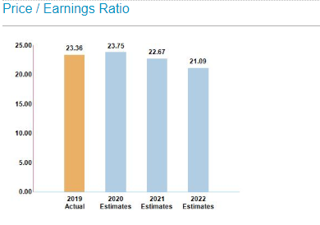
Success Factors and Risks
Walmart’s financial and strategic priorities have a great effect on accounting and business decisions. As such, the different divisions; that is, geographic structure, product structure, and function structure pose varied effects to the company’s structure. These structures affect accounting procedures based on the expected profit, estimated profits, and the result in cash flows. The Business decision is also influenced based on the assertion that the organization resources are supposed to be allocated based on the profitability of each organizational structure. A structure with an increased volume of returns is more likely to have a bigger allocation as opposed to others. Company’s financial and strategic priorities are likely to boost business success based on the assertion that they allow the business to maximize on the most profitable opportunities while recording increased sales and profitability (Martínez, Galván, &Alam, 2017). The practice encourages acute allocation of resources and proper business management, which are core tenets of business success. Overall, these prioritizations are likely to breed organizational growth and efficiency. Walmart relies on strategic planning for risk in addition to short-versus long term planning horizons.
The company can capitalize on nonfinancial factors by carrying out the persistent business evaluation. Such as practice will allow the firm to identify its areas of strength and weaknesses. The company should carry out fundamental market research to identify new business opportunities for execution (Martínez et al., 2017). The company can access greater market share through advertising their product. Walmart can gain reputation by focusing on establishing a good brand image via offering quality and reliable products to customers (Jahani et al., 2019). The company should also examine the customer’s response and take the initiative to improve is operation. It is worth to note that nonfinancial factors are the backbones of every effective and successful business, and hence, every business must pose growing attention.
The essential internal risks to the company’s financial performance include liquidity ratios. This refers to the company’s inability to meet both short-term and long term financial obligations due to the lack of adequate capital. Herein the company should ensure proper capital management. Another internal risk is leverage ratios, which included assessing the company’s internal policies on the usage of debt in addition to the mixed equity and debt in its capitals structure. Another internal risk is profitability ratio, which includes location assessment and marketing effectiveness in the entire business. These aspects call of internal changes such as training needs, regulatory compliance, and rental and maintenance rates (Alam, 2017). Also, rates of return within the company need to be evaluated through assessing competitive environment, which can lead to loss of highly talented employees, management capability, in addition to its internal procedures. Also, the company should pay attention to technological changes, which might lead to unauthorized access to the company’s information.
Projections
Based on Walmart Inc.’s annual financial reports for the past three years, the company has recorded a positive trend in its financial returns. As such, the company has experienced a gradual increase in its financial performance in the past years. I expect that Walmart will increase revenues due to the growing demand for its retail goods and services; with a hopeful increase in revenue by approximately 2.5% in the fiscal year 2019 and 2020. More importantly, the firm’s finance will continue to increase revenue in the United States and the global market as well, for the next three years. Assumedly, the company is expected to gain about 10-15% of its average financial performance in the next three years. Such a feature will make Walmart Inc. remain a global leader in both the current and future markets.
The best-case scenario of Walmart Inc. financial performance is that it will continue to gain revenue in the US economy and from the international markets. Herein, both domestic and global markets are likely to contribute up to 15% increase in financial performing in the next three years. However, this change will be noted if and only if the management is focused on expanding the firm’s core operations. If all operations are well managed, the company stands a chance to make a growth revenue up to $30 billion by 2022. The worst case scenario is likely to occur when the firm is not able to establish and maintain its brand more appropriately. Herein, the company will be faced with stiff competition and hence recording increasingly reduced returns in the short-run.
Accounting from the assumptions, I am fully convinced that the outlined projections are not overly aggressive. However, they are very attainable, by Walmart Inc.’s ambition to grow as well as expand their stipulated performance lines and hence recording improved financial returns. In my conviction, these projection assumptions may end up being very modest by serving as the most appropriate and immediate goals which the company can attain in the long-run. Effective attainment to the assumptions mentioned above will possibly stimulate Walmart’s global penetration. Changing the assumptions may lead to reduced commitment in company objectives as a result of easily achievable projections.
Business Opportunities
Walmart Inc. is a highly lucrative organization featured with good management team. The company has been able to maximize on provision of goods and services to its good and reliable customers. However, there is a need to deploy a lot of concern to the chief business opportunities for growth and efficiency. According to my understanding, Walmart should make mega-investment in e-commerce by adopting online marketing apps, which will increase the accessibility and availability of Walmart good and services to the end-user. Such an investment will also pave the way for reducing the cost of investment in addition to lowering the cost of operation (Archer, 2016). The main rationale for adopting this mode of investment is that Walmart is a global company, and hence, its goods and services should be digitalized to cope with the demands of the internet edge generations. Investing in e-commerce relies on powerful electronic gadgets and quite skillful IT personnel.
Analytically, every investment seems to be expensive in the short run, but quite effective and promising in the long run. Herein, Walmart is likely to encounter a lot of difficulties in investing in e-commerce due to the outstanding cost (Archer, 2016). The estimated cost of investing in e-commerce (online marketing) is USD$20 billion. The specific benefit of this investment is that it will create a great pool of customer across the world. The company will benefit from the reduced cost of advertisement since its goods and services will be suitably displayed on the online marketing apps. The company is likely to encounter an increased volume of sales and improved rate of stock turnover as a result. This investment if likely to the outlined in spreadsheets by making great changes to the consolidated financial performance. It will also help in making changes in business decisions such as laying out a fully effective business plan.
Effective investment in e-commerce implies that that the company must review its investment budgets to allocate adequate capital which would support enactment of the entire project. The potential investment will also call for adequate supplementary funds to cater for all unforeseen expenses, which might come as a result of project unfolding (Alam, 2017). More importantly, the company’s potential investment will call for improved business decision in regards to the acquisition and allocation of resources. As such, the company will require a reduced number of employees due to the digitalization of services. The firm will be required to drop labor-intensive modes of production and cope with capital-intensive modes of operation. The investment will be followed with improved sales in the next year, and hence, a lot of concern must be deployed on how to manage resources and maximize on the outstanding opportunities for efficiency. Based on this potential investment, the company is likely to opt for increased spending in the short term to subscribe to mass benefits in the long-term. It is with no doubt that the benefits of investing e-commerce are very great as opposed to risks.
References
Alam, S. (2017). Financial Analysis of Retail Business Organization: A Case of Wal-Mart Stores, Inc. Inc.(April 4, 2017).
Archer, J. (2016, September 27). Why successful companies keep investing in ongoing marketing. Retrieved March 05, 2017, from https://crowdfavorite.com/why-successful-companies-keep-investing-in-ongoing-marketing
Cooley, J. (2018). Introduction: Business-to-Business Marketing in China: Digital or Traditional? In The Digitization of Business in China (pp. 1-40). Palgrave Macmillan, Cham.
Flammer, C. (2015). Does corporate social responsibility lead to superior financial performance? A regression discontinuity approach. Management Science, 61(11), 2549-2568.
Jahani, H., Abbasi, B., &Talluri, S. (2019). Supply Chain Network Redesign: A Technical Note on Optimising Financial Performance. Decision Sciences.
Martínez, A. B., Galván, R. S., &Alam, S. (2017). Financial Analysis of Retail Business Organization: A Case of Wal-Mart Stores, Inc. Nile Journal of Business and Economics, 3(5), 67-89.

Appendix
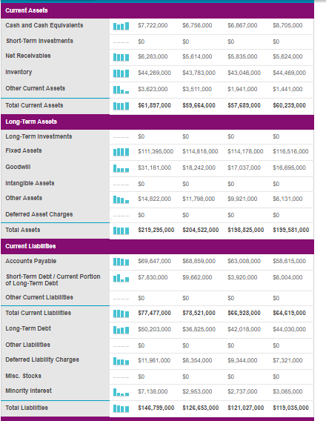
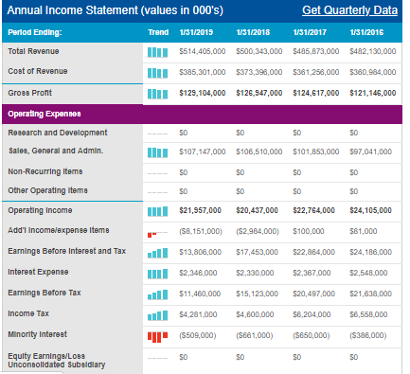

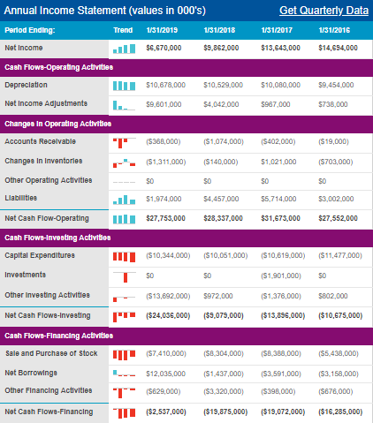

Current Financial Analysis
